Masonic Symbolism in the Middle Ages
The Wayfarer by Hieronymus Bosch (@ 1500-1510)
Masonic scholars continue to research historical documents that provide a glimpse or purpose of the fraternity's true origin. Since secret society did exist in medieval Britain, it would be much simpler for an artist to conceal its symbolism and allegory in his paintings than for a chronicler to attempt to conceal them in his writings. This painting is an outstanding example of such a possibility.
The accepted history of Freemasonry encompasses the origins, evolution and defining events of the fraternal organization known as Freemasonry covering three phases. Firstly, the emergence of organized lodges of operative masons during the Middle Ages, then the admission of lay members as "accepted" or speculative masons, and finally the evolution of purely speculative lodges, and the emergence of Grand Lodges to govern them. The watershed in this process is generally taken to be the formation of the first Grand Lodge in London in 1717; however, visual evidence may indicate an earlier application of Freemasonry
The Wayfarer was painted by Hieronymus Bosch (1450-1516) resides at the Museum Boymans-van Beuningen in Rotterdam. Bosch was a Flemish painter who worked within the Northern Renaissance Period. Those familiar with Bosch's work have come to expect graphic portrayals of a wide range of hideous, distorted demons. The Wayfarer is different in that it depicts no demons or monsters, although it is packed with symbolism, much of it Masonic in nature.

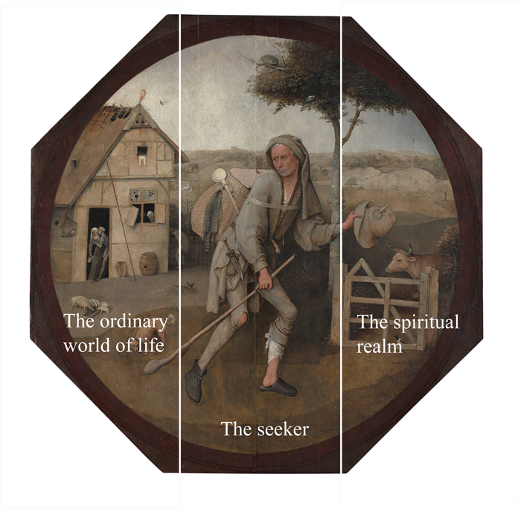
Figure 1
Details:
This image shows the painting in its entirety, distributed into three sections as a triptych.
The first section, The ordinary world of life depicts the reality of despair and destitution. As a visual aside, The seeker is moving from left to right or directionally, from West to East.
The second section shows The seeker, within the present, looking back towards the past but prepared to enter the future.
The third section, The spiritual realm, holds the promise of improvement.
Figure 2
Details:
The traveler (wayfarer) has his left trouser leg pushed up to the knee. Some critics point out that the trouser leg is up to accommodate a bandage, but no minor calf wound requires a slipper on one foot, with a shoe on the other, or in other terms, “slipshod”.
The straps on the wayfarer's backpack are not over his shoulders where they belong. Instead, Bosch painted a strap around his upper arms, binding him like a Masonic cable-tow. The feather we might expect to find in his hat is not there. Bosch has replaced it with a plumb bob, another Masonic symbol.
Why is the man carrying his hat in his hand, rather than conveniently wearing it on his head? Bosch may have wanted his hood ready to pull down over his face to "hoodwink" him, a word that suggests that this is the way a man was blindfolded in ancient Masonic initiation. It was a common practice at that time and was incorporated into the language for future ages in "to pull the wool over his eyes."
Ahead of the traveler is a gate with a strange brace. Everyone who knows anything about wooden farm gates knows that the brace goes from one corner to the diagonally opposite corner, creating immovable triangles. The brace on Bosch's gate rises above the top rail, and then comes back down to the corner. This produces a craftsman's square on top of the gate.
Within a few steps the wayfarer will pass through the gate of the square and enter a landscape of peace and plenty (beauty), as symbolized by the placid milk cow. With mental fortitude (strength), the traveler walks under a tree with a perched owl, the medieval symbol of wisdom. In a backward or reverse retrospect, the wayfarer is about to enter the realm of wisdom, strength and beauty-known as the triads or "lesser lights" included in the moral teachings of Masonry.
The final question in this discourse is one of motivation. To have known the Masonic symbols before 1717 (if indeed they existed in his time); Bosch would have to have been a Masonic initiate. Therefore, it is likely that the painter was attracted to, and invited into, a secret society dedicated to protecting religious dissidents from the wrath of the church. Also, Bosch was known to have been a member of a religious fraternity frowned upon by the church. His cynical portrayals of drunken, carousing monks and nuns indicate a man angry at the church, especially in view of several condemnations of his work as heretical.
Some critics may argue that the esoteric symbols in this painting are all merely coincidences. If so, this is the most incredible 30 collection of Masonic coincidences that we may ever expect to see assembled in a single work. If, however, the symbols are not there coincidentally, then this painting provides the very first graphic evidence of the existence of Masonic symbolism over five hundred years ago, in the late fifteenth century.
Citation:
http://www.knightstemplar.org/KnightTemplar/articles/20081112.htm
